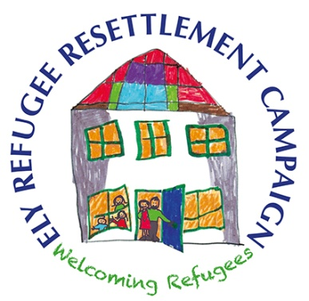

Questions for prospective parliamentary candidates
May 2017

- What is your party’s stance on helping refugees?

- What is your party’s policy on the continuation of the Syrian Vulnerable Persons Resettlement Scheme?

- What is your view on the resettlement of refugees in South East Cambridgeshire? (To date, one family has been resettled in Ely, with work being undertaken to bring a few more families to the area.)

- If you are elected, how will you help to support local efforts to resettle Syrian refugees in South East Cambridgeshire?

- Will you call for the Dubs amendment to be reconsidered, or to call for other definite ways to help protect and give sanctuary to unaccompanied refugee children?

